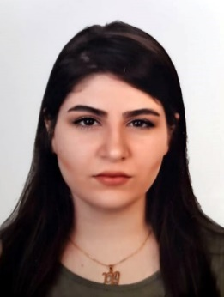

Name: Marina Nazar Ismaeel

Date of Birth: 3 Sept. 1997

Address: Erbil- Ainkawa

Nationality: Iraqi

Gender: female

Marital status: Single

Phone no. 07707866380

Email: marinanazar1997@yahoo.com

**Education**

**Noble institute – Business Management of oil and gas**

**Work Experience**

## HR Trainee (July-August 2017)

Sardar Auto Company – Sardar Group

I worked as a trainee under the supervision of the direct manager of the department and participated in:

* Registering employees’ inquiries and responding to them.
* Organizing files and number them according to work demands.
* Inserting personal information of the employees according to a set program in the computer.
* Organizing meeting room, preparing stationery and date shoe …...etc.

## Logistics Assistant (August-September 2017)

Sardar Auto Company – Sardar Group

As a trainee (mentioned above) I helped in:

* Receiving shipment documents of loaded vehicles as mentioned in computer.
* Checking shipment papers with the information already sent to the department.
* Checking chassis numbers and vehicles colors loaded.
* Checking the vehicles cost.

(August – September 2017)

**Another interests:**

* Worked as volunteer in Hobby organization for helping orphan kids.
* Worked as volunteer in Smile Team, handcrafts work behind the scenes.

**Computer Skills**

* M.S Office (Word, Excel,)
* Using internet

**Languages**

|  |  |  |  |
| --- | --- | --- | --- |
| Language (Verbal) | Speak | Write | read |
| English | well | Good | Good |
| Arabic | Mother tongue | excellent | excellent |
| Kurdish | Well |  |  |